Electronic supplementary information

sInthesIs of nonconjugated TADF polymers
WITH different main chains

R. A. Polyakov,* O. V. Borshchev and S. A. Ponomarenko

Institute of Synthetic Polymeric Materials, Russian Academy of Sciences,
ul. Profsoyuznaya 70, Moscow, 117393 Russia

Table of contents

1. Experimental section S2
2. ¹H and ¹³C NMR spectra S4
3. MALDI analysis results S9
4. TGA data S11
5. References S12

1. Experimental section
Measurements and characterization
The ¹H and ¹³C NMR spectra were recorded on a Bruker WP-250 SY spectrometer at 250 MHz using CDCl₃ (δ = 7.25 ppm) as a reference. The ¹³C NMR spectra were recorded on a Bruker Avance II 300 spectrometer at 75 MHz. The samples were dissolved in CDCl₃ to the concentrations of 1 and 5% for ¹H and ¹³C NMR, respectively. The spectra were processed using the ACD Labs software.
The thermogravimetric analysis (TGA) was carried out using a TG50 Mettler Toledo system with a weight accuracy detection up to 1μg in a dynamic mode in the range from 20 to 700 ℃. The heating rate was 10 deg/min in the air or argon atmosphere.
The high-resolution mass spectra (HRMS) were recorded on a Maxis instrument (Bruker Daltonics, Germany) using electrospray ionization. The measurements were performed in a positive ion mode (interface capillary voltage -4500V); the mass range from m/z 50 to m/z 1800 Da; the external calibration with the Electrospray Calibrant Solution.
The gel permeation chromatography (GPC) of small molecules was performed on a Shimadzu instrument equipped with a RID10AVP refractometer, an SPD-M10AVP diode array detector, and a 300×7.8 mm column (Phenomenex, USA) filled with Phenogel (pore diameter 500 Å, Phenomenex, USA); column temperature 40 ± 0.1 ℃; eluent tetrahydrofuran. The GPC analysis of the polymers was performed on a system consisting of a Stayer s. 2 high-pressure pump (Akvilon, Russia), a SmartlineRI 2300 refractometric detector (Knauer, Germany), and a JETSTREAM 2 PLUS column thermostat (Knauer, Germany). The thermostat temperature was 40 ± 0.1 °С. Toluene–THF (100%–2%) at a flow rate of 1.0 mL/min was used as an eluent. The column was filled with sorbent Phenogel (Phenomenex, USA), the particles size was 5 μm, the pore size was 10⁴ Å, the column length and diameter were 300×7.8 mm. The results were processed using the MultiKhrom 1.6 GPC (Ampersend, Russia) relative to polystyrene standards.
A CEM Discover microware system of organic synthesis was used for the reactions at the temperature of 105 ℃ and power of 55 W during 3 h.
Materials
Commercial 4-bromostyrene (98%, ABCR), cyanuric chloride (98%, Central Drug House), phenylboronic acid (98%, ABCR), carbazole (98%, Macklin), platinum divinyltetramethyldisiloxane complex in xylene (2.1-2.4%Pt, abcr), Pd(dba)₂ (97%, Macklin), Pd(PPh₃)₄ (99%, Macklin), tri-tert-butylphosphine (98%, Sigma-Aldrich), polymethylsiloxane-60 (PMS-60, Penta-91), potassium carbonate (chemically pure, Vecton), AIBN (chemically pure, Vekton), anhydrous sodium sulfate (chemically pure, Lenreaktiv) were used. Toluene (analytical grade, Vekton), dichloromethane (analytical grade, Vekton), tetrahydrofuran (chemically pure, EKOS-1), cyclohexane (analytical grade, EKOS-1), diethyl ether (analytical grade, Vekton), carbon tetrachloride (chemically pure, Chemical Reagent Base No. 1) and n-pentane (chemically pure, Komponent-Reactiv).
Syntheses
9-(4-Ethenylphenyl)carbazole was prepared according to the published procedure [S1]. 2,4-Dichloro-6-(4-ethenylphenyl)-1,3,5-triazine and 2-(4-ethenylphenyl)-4,6-diphenyl-1,3,5-triazine were synthesized by the methods described elsewhere [S2]. The synthesis of Si-10 and Si-50 was carried out by the reported procedure [S3].
9-(4-Ethenylphenyl)carbazole (donor). Yield: 82%. ¹H NMR (300 MHz, CDCl₃): δ 5.45 (d, J = 10.68 Hz, 1H), 5.94 (d, J = 17.40 Hz, 1H), 6.79 (dd, J = 10.90, 17.40 Hz, 1H), 7.54 (d, J = 8.55 Hz, 2H), 8.46 (d, J = 8.55, 2H) ppm. ¹³C NMR (75 MHz, CDCl₃): δ 141.07, 136.99, 136.14, 127.66, 127.23, 126.01, 123.62, 120.33, 114.71, 109.88 ppm.
2,4-Dichloro-6-(4-ethenylphenyl)-1,3,5-triazine. Yield: 50%. ¹H NMR (300 MHz, CDCl₃): δ 5.40 (d, J = 10.99 Hz, 1H), 5.93 (d, J = 17.70 Hz, 1H), 6.84 (dd, J = 10.99, 17.70 Hz, 1H), 7.59 (m, 8H), 8.76 (m, 6H). ¹³C NMR (75 MHz, CDCl₃): δ 174.11, 171.71, 143.58, 135.62, 131.65, 129.97, 126.46, 117.14 ppm.
2-(4-Ethenylphenyl)-4,6-diphenyl-1,3,5-triazine (acceptor). Yield: 37%. ¹H NMR (300 MHz, CDCl₃): δ 5.37 (d, J = 10.99 Hz, 1H), 5.86 (d, J = 10.99, 17.40 Hz, 1H), 6.86 (dd, J = 10.99, 17.70 Hz, 1H), 7.26–7.32 (m, 2H), 7.40–7.44 (m, 4H), 7.53 (m, 2H), 7.64 (m, 2H), 8.15 (m, 2H). ¹³C NMR (75 MHz, CDCl₃): δ 171.71, 171.39, 141.69, 136.47, 135.78, 132.39, 129.29, 129.02, 128.59, 126.45, 115.81 ppm.
General procedure for the synthesis of polymers Si-10 and Si-50. A flask was charged with a solution of organosilicon polymer PMS-60 (1 equiv.) in 10 mL of dry toluene under an inert atmosphere. The reaction mixture was heated to 70 °С, then a solution of 9-(4-ethenylphenyl)carbazole and 2-(4-ethenylphenyl)-4,6-diphenyl-1,3,5-triazine (ratio of the reagents: 0.5 equiv.:0.5 equiv. in the case of Si-50, 0.9 equiv.:0.1 equiv. in the case of Si-10) in 10 mL of dry toluene and 50 μL of Karstedt's catalyst were added dropwise. After stirring at 90 °С for 48 h, the resulting mixture was passed through a silica gel layer in toluene. The mixture was concentrated on the rotor evaporator and dried on an oil pump. The target polymers were purified by the precipitation from a toluene solution with n-pentane. After purification and drying, the yields of the products were 47–70%.
Si-10. Yield: 553 mg (47%). ¹H NMR (300 MHz, CDCl₃): δ –0.16–0.49 (m, 30H), 0.73–1.21 (m, 10), 1.22–1.74 (m, 12H), 1.99–2.46 (m, 8H), 2.47–2.94 (m, 10H), 6.80–7.53 (m, 19H), 7.71–8.22(m, 20H), 8.33–8.75 (m, 5H) ppm.
Si-50. Yield: 376 mg (70%). ¹H NMR (300 MHz, CDCl₃): δ –0.2–0.35 (m, 6H), 0.69–1.59 (m, 4), 1.90–2.93 (m, 4H), 6.81–7.60 (m, 19H), 7.71–8.13(m, 2H), 8.19–8.72 (m, 6H) ppm.
General procedure for the synthesis of polymers C-10 and C-50. The polymers were obtained by the free radical polymerization with azobisisobutyronitrile (AIBN) as a radical initiator and THF as a solvent. AIBN was recrystallized from diethyl ester and THF was distilled prior to use to remove a stabilizer. To synthesize the polymers, the monomers and AIBN (2 mol % of the total amount of the monomers) were dissolved in THF with total concentration of ~0.3g/mL, which were then stirred at 50 ℃ for 48 h under an argon atmosphere. After cooling to room temperature, the mixture was precipitated with cold acetone and methanol subsequently. The resulting precipitate was filtered off and dried under vacuum to give the desired polymers as fibers in 64–78% yields.
C-10. Yield: 320 mg (78%). ¹H NMR (300 MHz, CDCl₃): δ 0.76–2.25 (m, 8H), 6.09–7.81 (m, 19H), 7.81–8.87 (m, 8H) ppm.
C-50. Yield: 359 mg (64%). ¹H NMR (300 MHz, CDCl₃): δ 1.08–2.67 (m, 40H), 6.24–7.47 (m, 104H), 7.49–8.81 (m, 16H), 8.16–8.61 (m, 3H) ppm.

2. ¹H and ¹³C NMR spectra
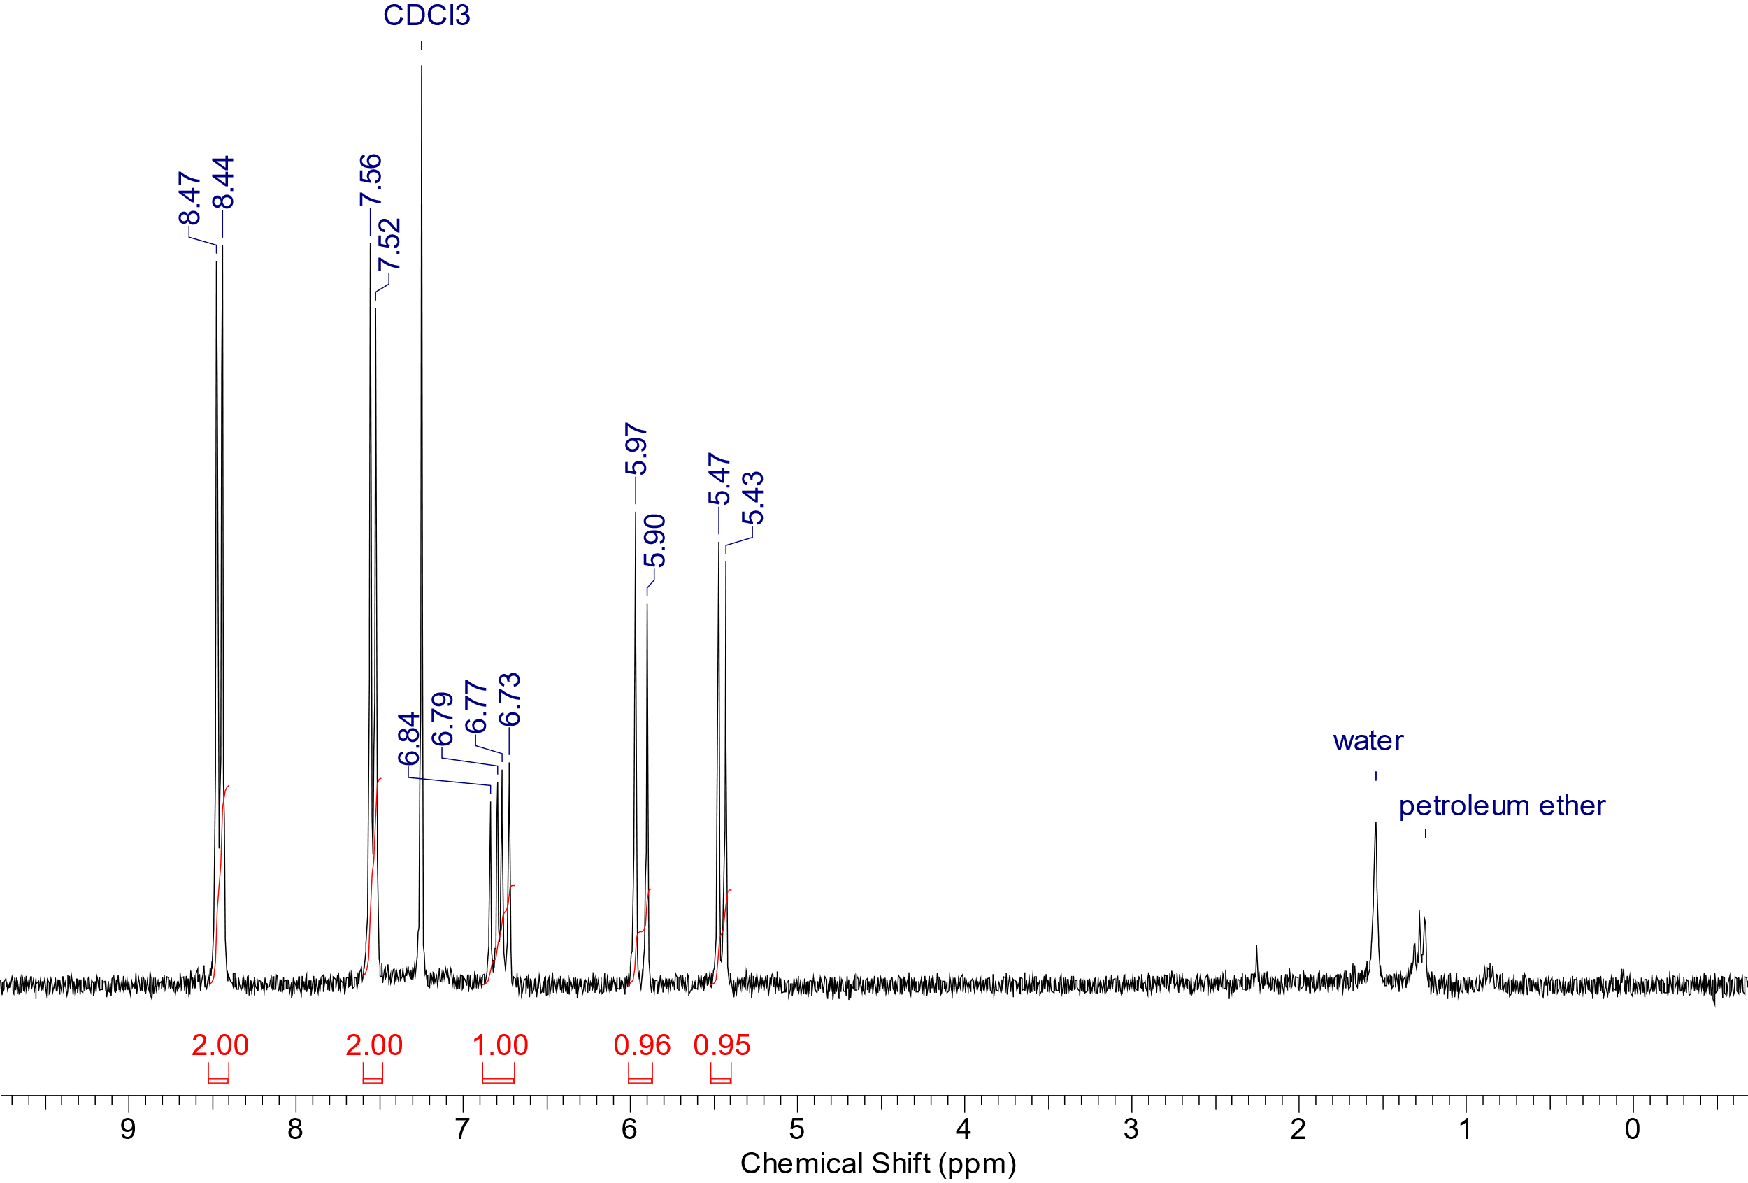
Figure S1. ¹H NMR spectrum of 2,4-dichloro-6-(4-ethenylphenyl)-1,3,5-triazine in CDCl₃.
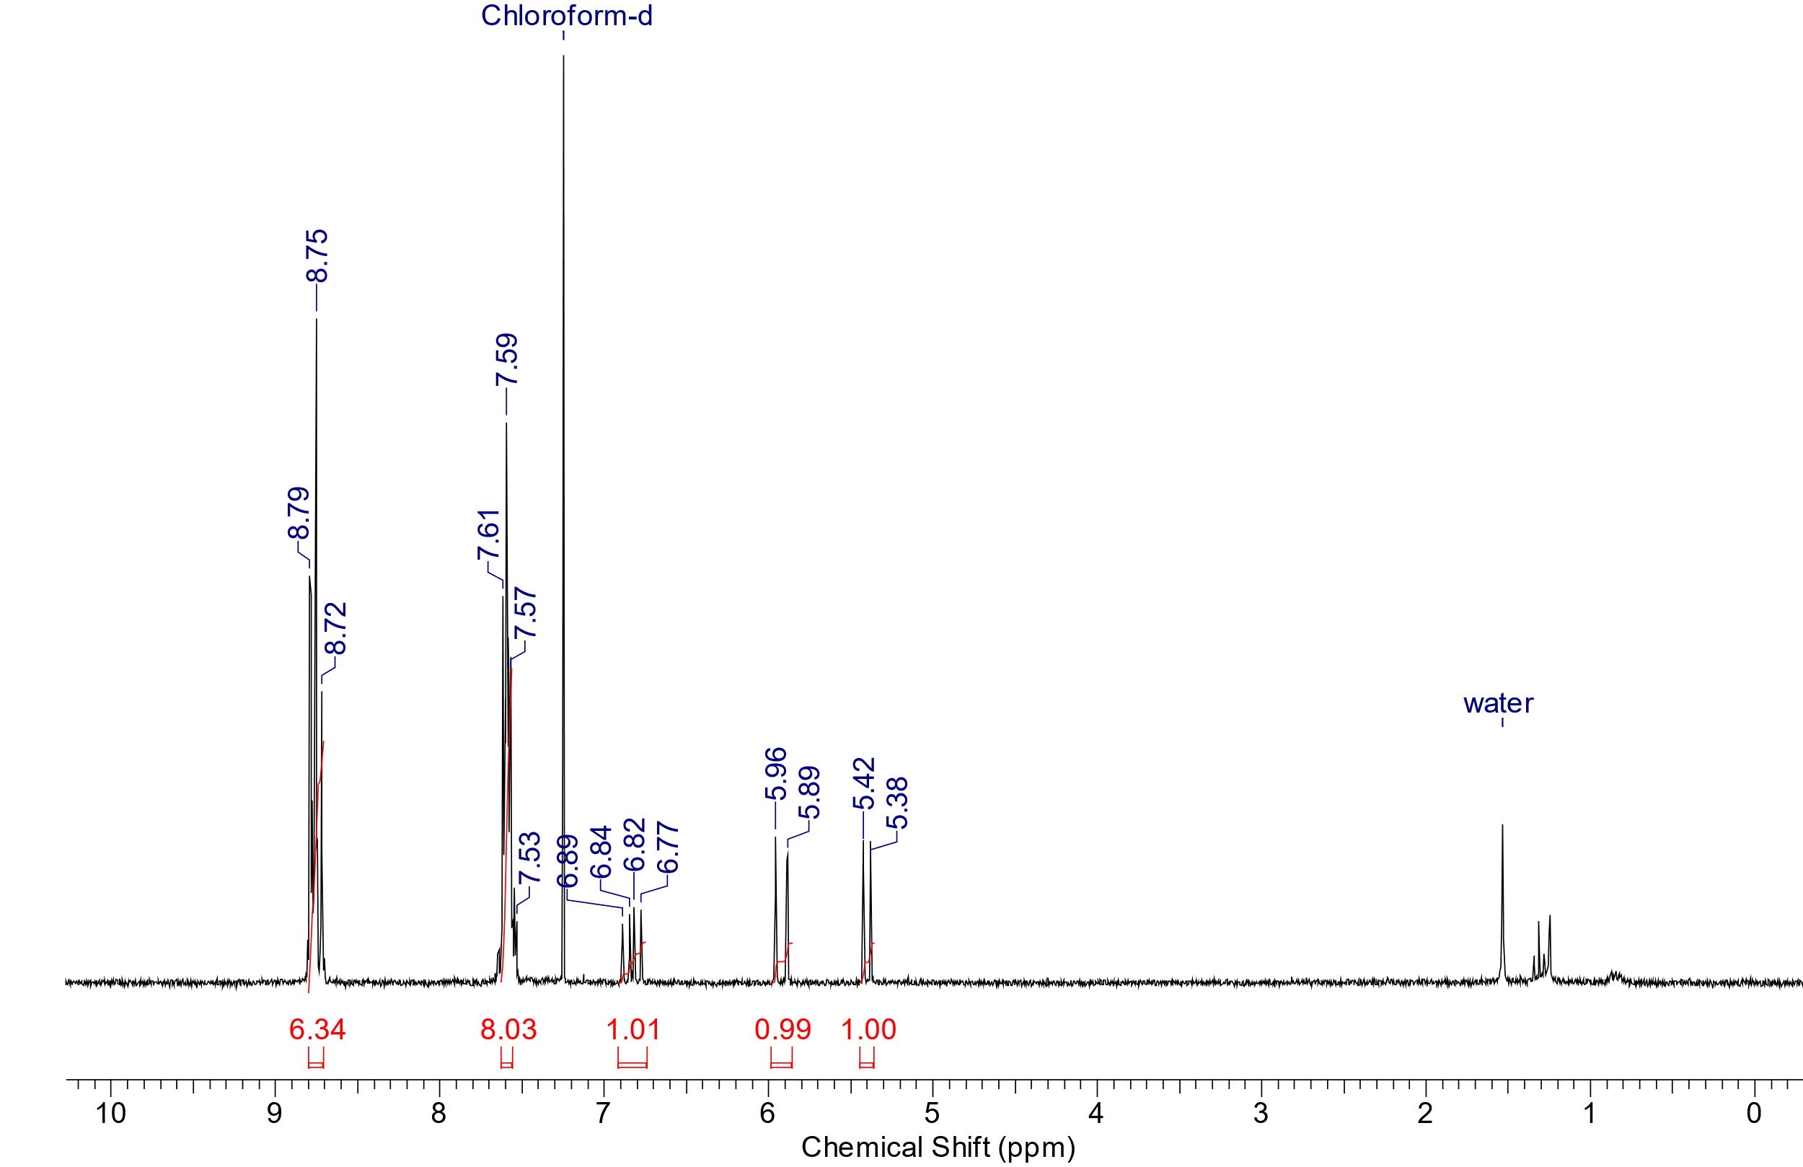
Figure S2. ¹H NMR spectrum of 2-(4-ethenylphenyl)-4,6-diphenyl-1,3,5-triazine (acceptor) in CDCl₃.
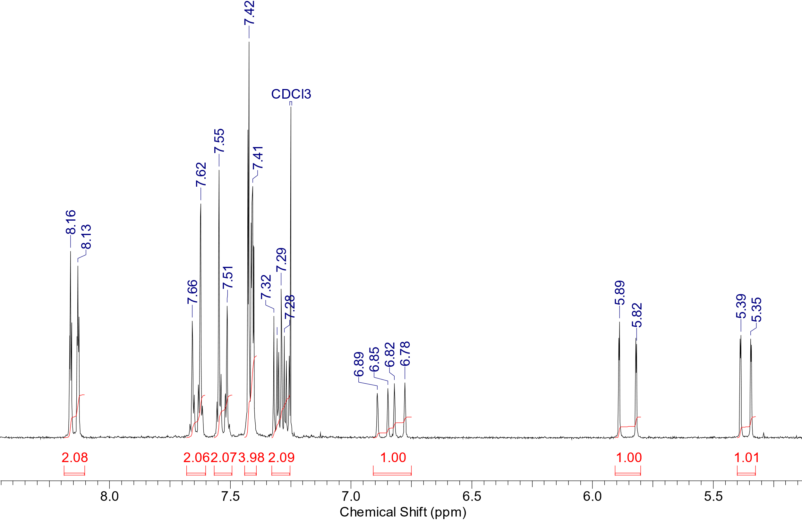
Figure S3. ¹H NMR spectrum of 9-(4-ethenylphenyl)-carbazole (donor) in CDCl₃.
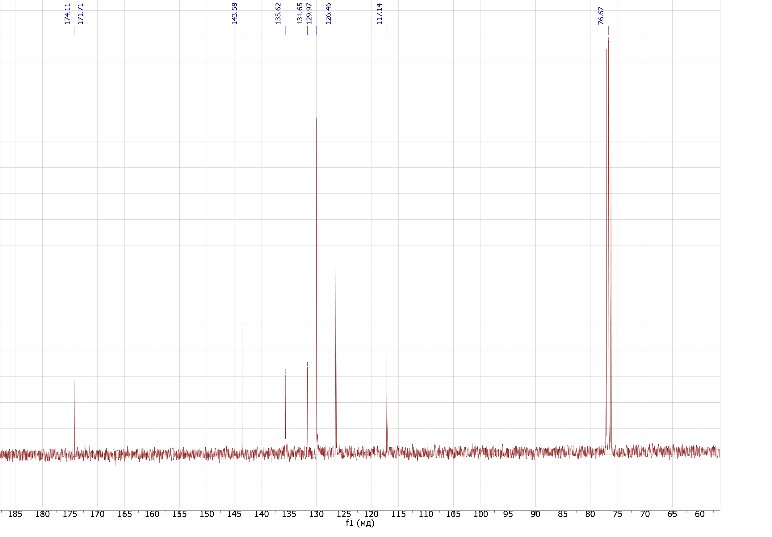
Figure S4. ¹³C NMR spectrum of 2,4-dichloro-6-(4-ethenylphenyl)-1,3,5-triazine in CDCl₃.
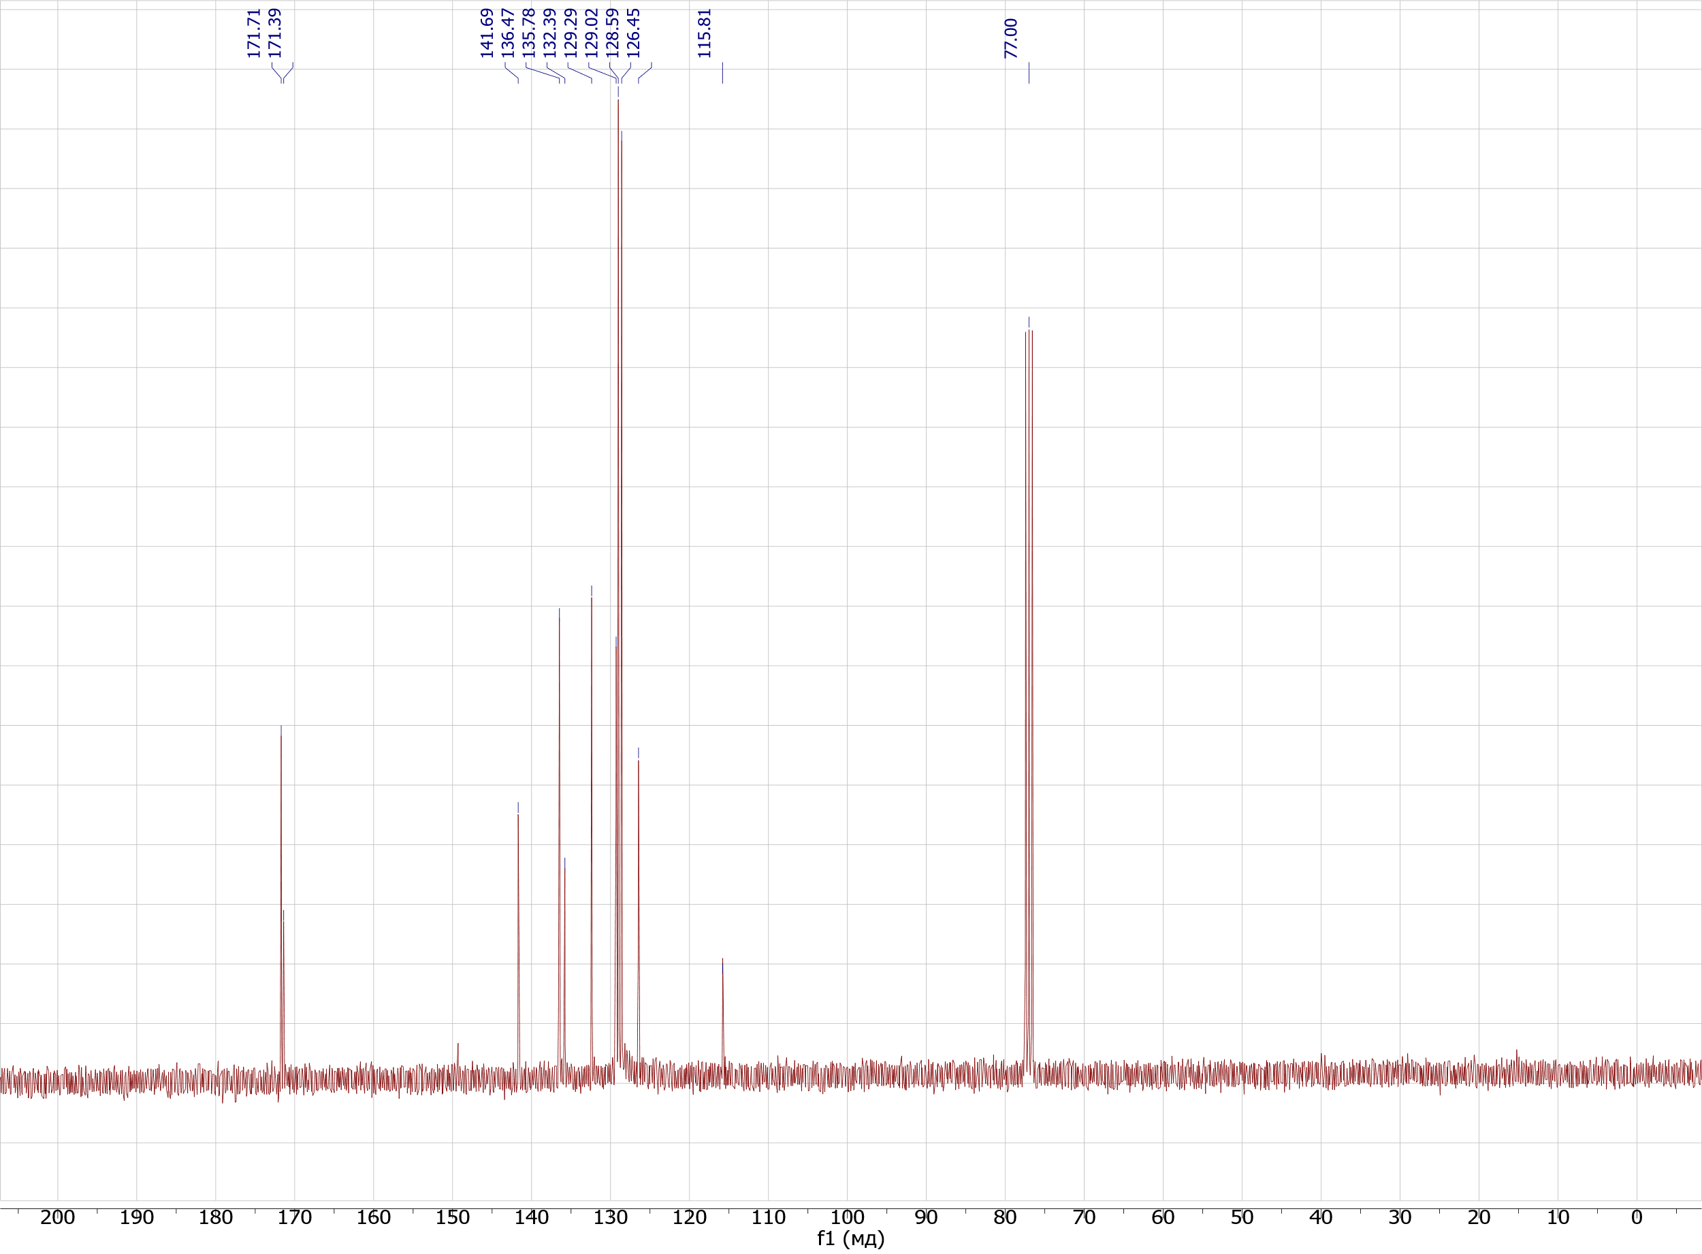
Figure S5. ¹³C NMR spectrum of 2-(4-ethenylphenyl)-4,6-diphenyl-1,3,5-triazine (acceptor) in CDCl₃.
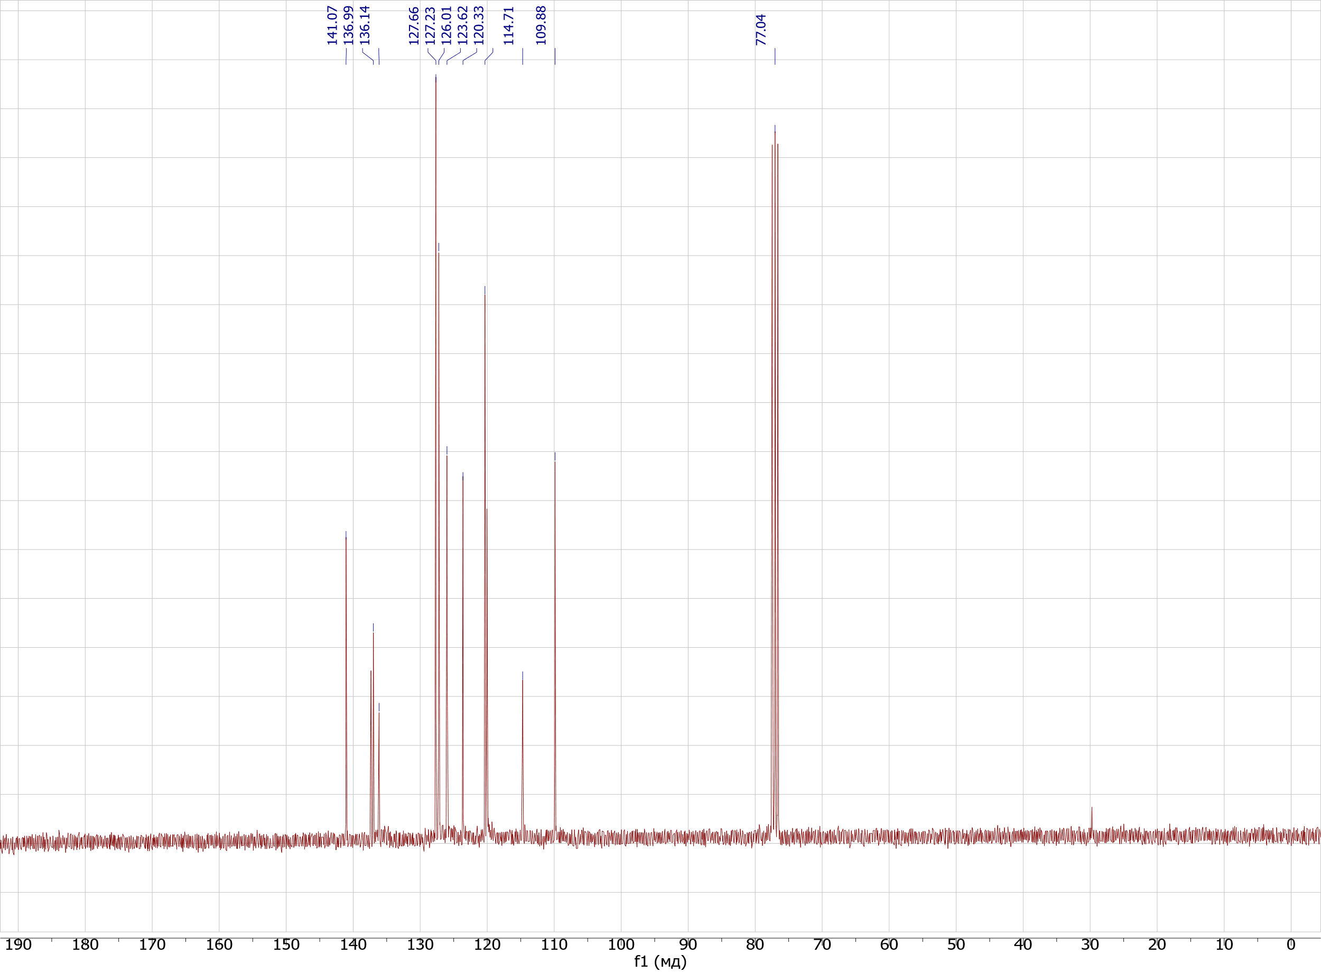
Figure S6. ¹³C NMR spectrum of 9-(4-ethenylphenyl)-carbazole (donor) in CDCl₃.
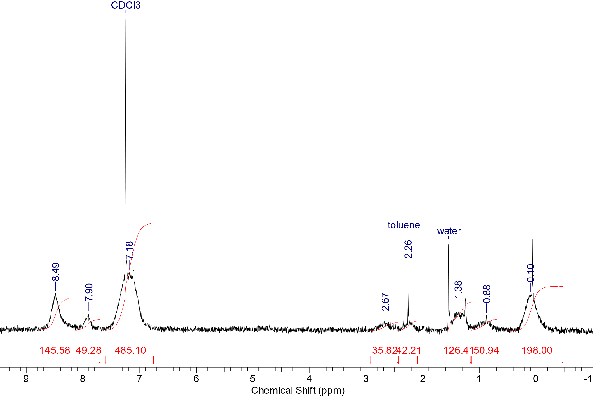
Figure S7. ¹H NMR spectrum of Si-50 in CDCl₃.
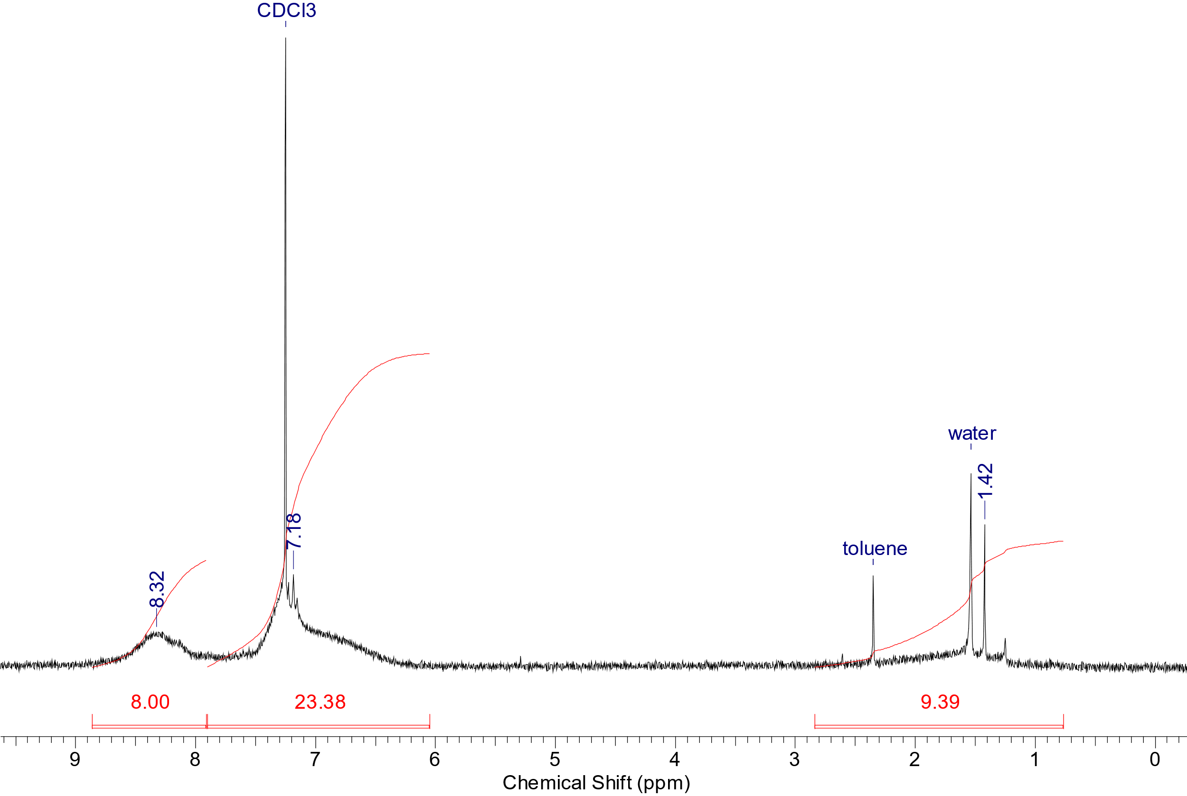
Figure S7. ¹H NMR spectrum of C-50 in CDCl₃.
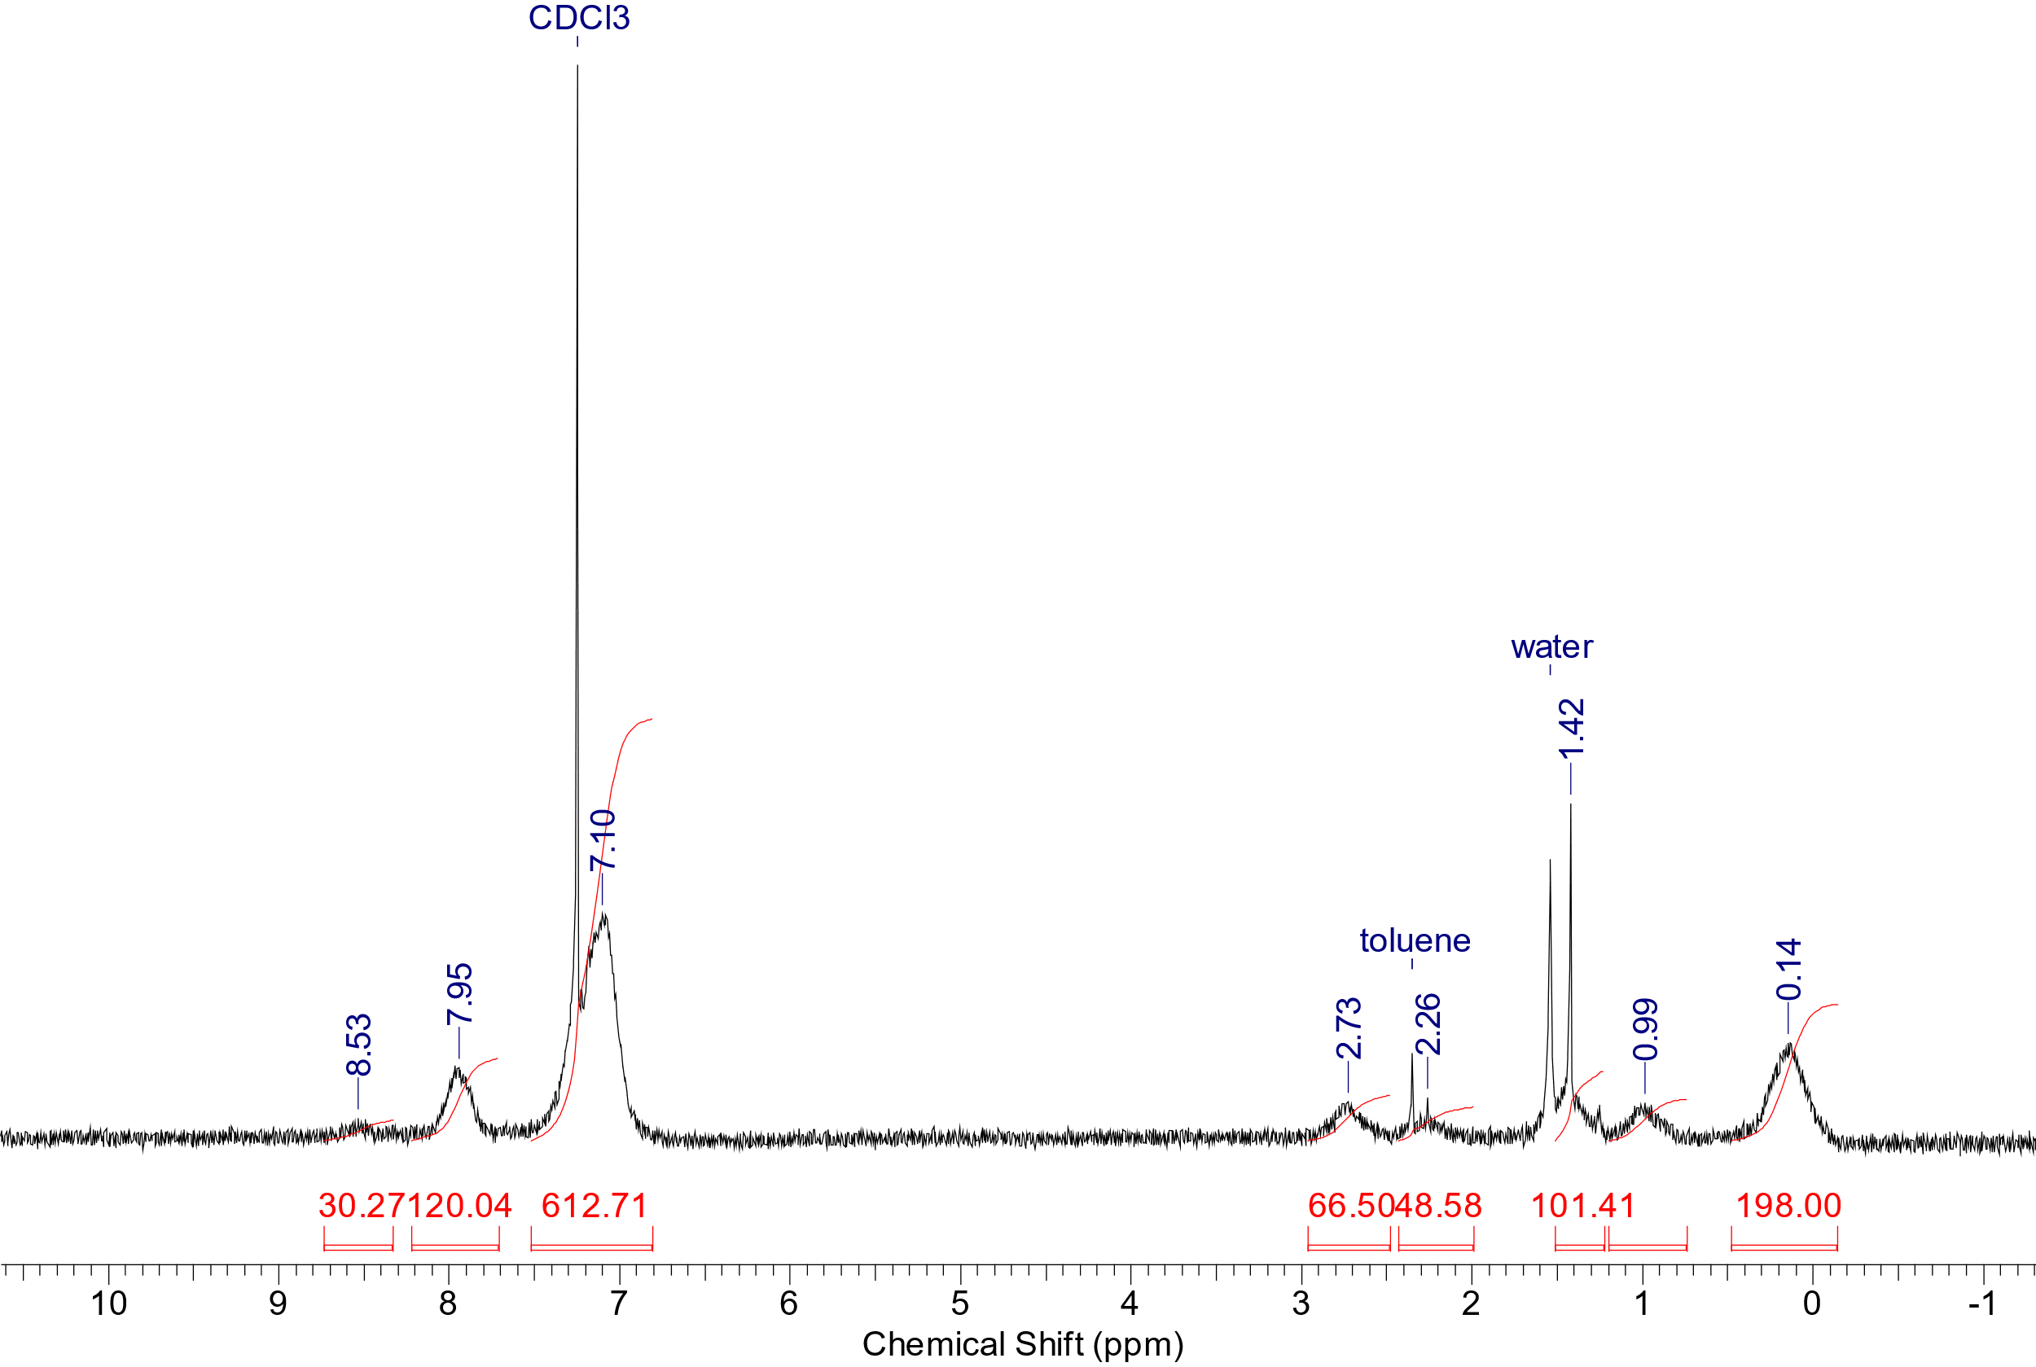
Figure S8. ¹H NMR spectrum of Si-10 in CDCl₃.
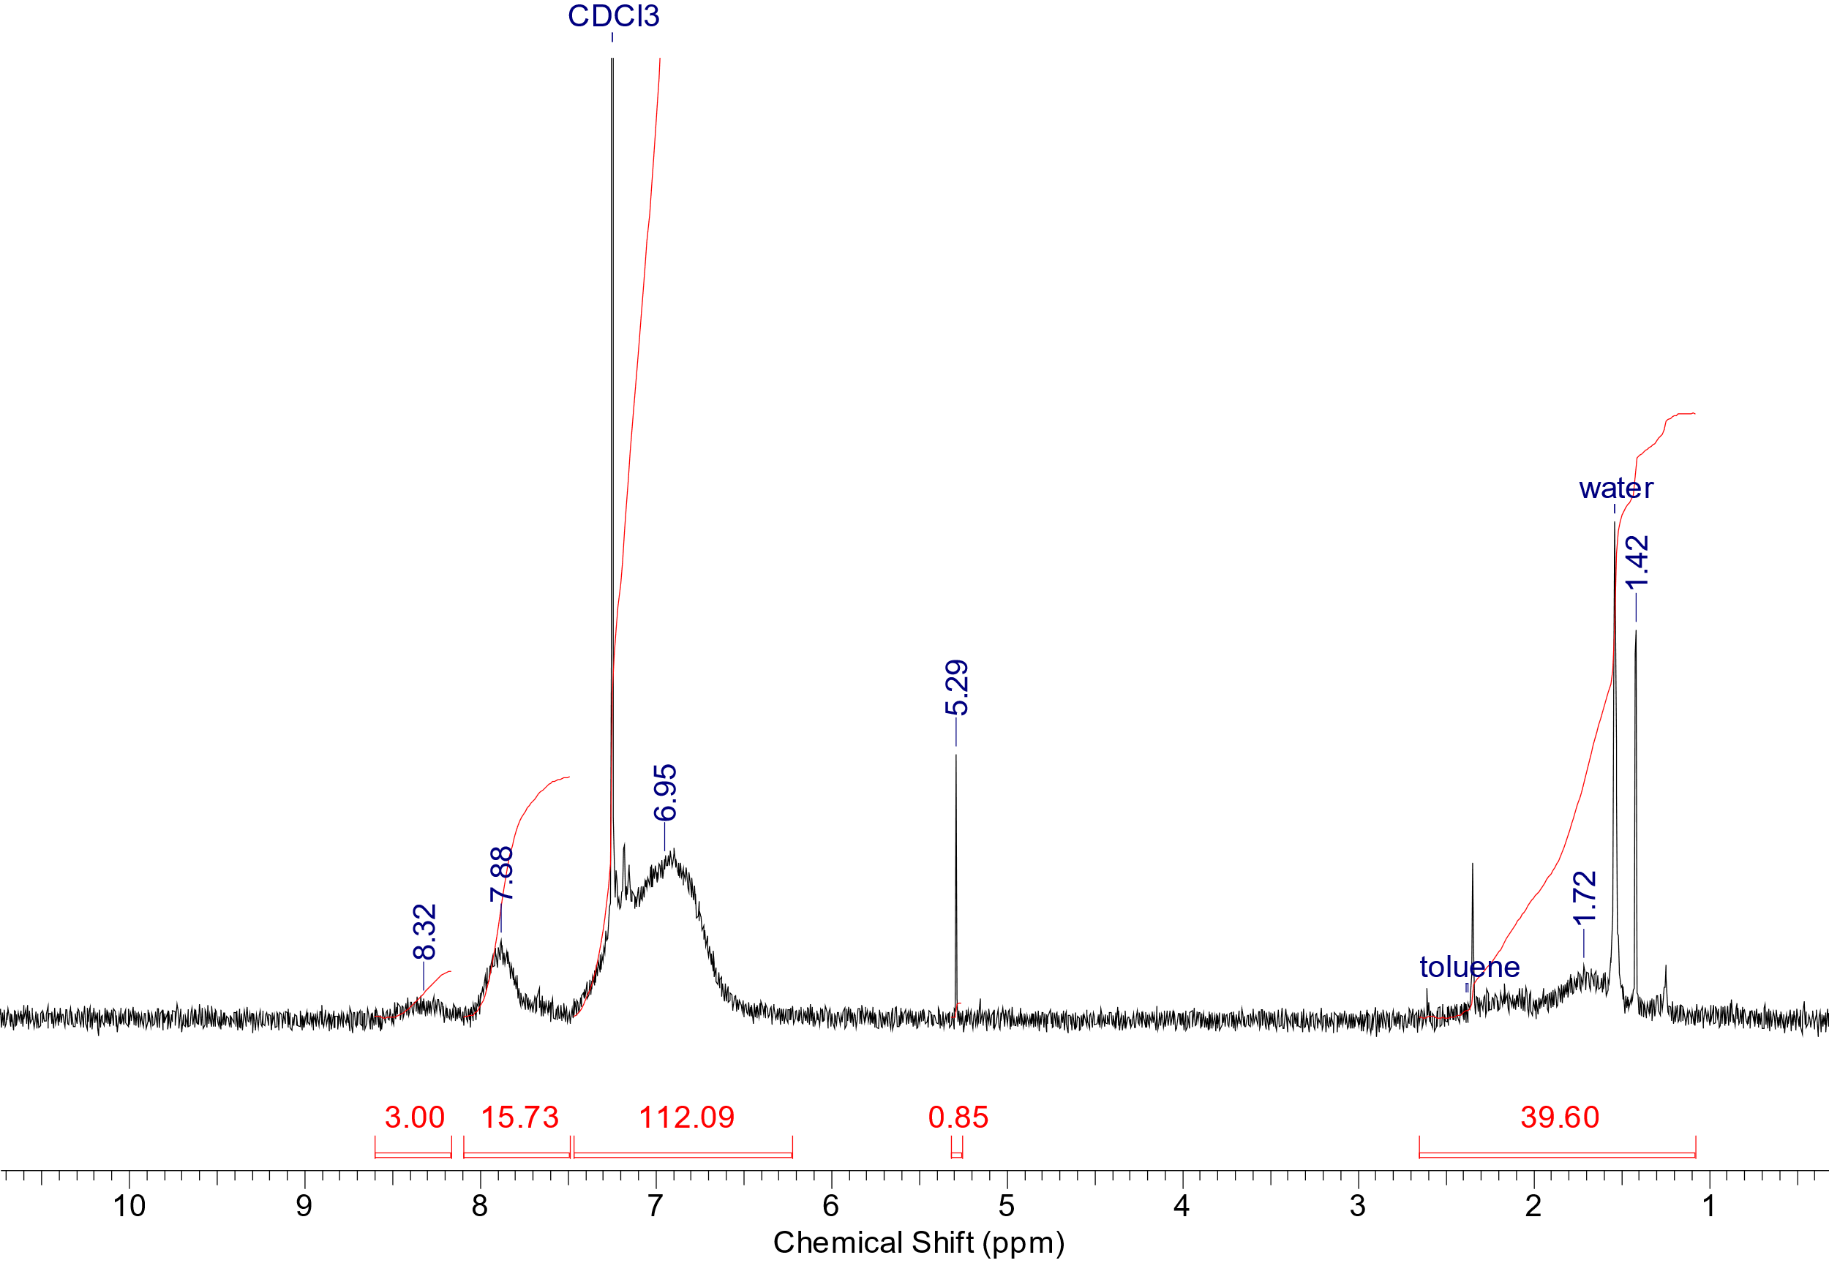
Figure S9. ¹H NMR spectrum of C-10 in CDCl₃.

3. MALDI analysis results
Figure S10. Experimental and simulated HRMS spectra of
2,4-dichloro-6-(4-ethenylphenyl)-1,3,5-triazine.
Figure S11. Experimental and simulated HRMS spectra of 2-(4-ethenylphenyl)-
4,6-diphenyl-1,3,5-triazine (acceptor).
Figure S12. Experimental and simulated HRMS spectra of 9-(4-ethenylphenyl)-carbazole (donor).

4. TGA data

Figure S13. Thermogravimetric analysis (TGA) in the argon flow.

Figure S14. Thermogravimetric analysis (TGA) in the air flow.

5. References
S1. A. A. Vaitusionak, I. V. Vasilenko, G. Sych, A. V. Kashina, J. Simokaitiene, J. V. Grazulevicius, S. V. Kostjuk, Eur. Polym. J., 2020, 134, 109843. DOI: 10.1016/j.eurpolymj.2020.109843
S2. M. Yu, Y. Gao, A. Ying, L. Li, G. Xie, S. Gong, X. Gao, T. Wang, C. Yang, Macromolecules, 2023, 56, 5381–5389. DOI: 10.1021/acs.macromol.3c00601
S3. E. A. Zaborin, O. V. Borshchev, M. S. Skorotetskii, V. V. Gorodov, A. V. Bakirov, M. S. Polinskaya, S. N. Chvalun, S. A. Ponomarenko, Polym. Sci., Ser. B, 2022, 64, 841–854. 10.1134/S1560090422700427

